Meta Title: Bet99 Ontario vs. BetMGM Ontario: Who Pays Out Faster?
Meta Description: Compare tested payout speeds across licensed Ontario online casinos. This Bet99 vs. BetMGM Ontario comparison covers UX, banking options, and more.

Bet99 vs BetMGM Ontario - Which Casino Actually Pays Within 24 Hours?
Game depth and intuitive UX means little if withdrawals are drawn out. That’s why I put Bet99 Casino Ontario and BetMGM Casino Ontario, two of the most popular Ontario online casinos, through the paces. I tested everything from user interface to banking options and payout speeds.
In this comprehensive Bet99 vs. BetMGM Ontario comparison, I’ll break down the key differences between these two licensed Ontario casinos to see which one actually delivers same-day payouts.

Bet99 vs. BetMGM Ontario: Quick Comparison Table
Feature | Bet99 Ontario | BetMGM Ontario
ON Launch date | October 2022 | April 2022
AGCO licensing status | Active | Active
Minimum deposit | $20 | $10
Casino games count | 3,000+ | 6,700+
Withdrawal availability | 24/7 | 24/7
Max withdrawal amount | Up to $100,000 | Up to $50,000
Average payout speed | 1 business day | Within 24 hours
Mobile app | Yes (Android & iOS apps) | Yes (Android & iOS apps)
Top payment options | Interac, Visa, MasterCard, PayPal, Trustly, MuchBetter, Apple Pay | Visa, MasterCard, PayPal, Interac e-Transfer, Apple Pay, MuchBetter
Unique Features | - A Toronto-based brand  - Simple site design  - 28+ Bet99 Exclusives | - Award-winning online casino  - 6,700+ high-quality games  - 750+ BetMGM exclusives
Since its debut in 2022, Bet99 Ontario has established itself as a Toronto-based operator that offers a well-rounded experience. In terms of payouts, what stood out most about Bet99 Ontario casino was its transparent withdrawal policy. While most licensed sites bury their payout details in fine print or behind account verification, Bet99 Casino clearly displays its withdrawal policy in the footer.
BetMGM Ontario also went live in the Loyalist province in 2022 and its familiar iconic lion and all-star brand ambassadors have been riding Ontario airwaves ever since. While its 6,700+ deep library, useful filter tools, and highly ranked iOS and Android apps make it one of Ontario’s favourites, the 6+ payout options and low withdrawal minimums is what stood out during testing.
Read on for a full breakdown of how Bet99 and BetMGM compare in withdrawal UX, verification and security checks, payment options, and more.

Withdrawal User Experience: Bet99 is Easier to Navigate
Among the best Bet99 Ontario features is its easy to use and well-organized layout. Its dark, modern interface with bright neon green buttons made it easier to browse through the platform.

Account creation was straightforward and after my Bet99 Casino login, the cashier window was always a single click away. Withdrawal methods were clearly displayed alongside their minimum and maximum limits, while I could also track my withdrawal status from the cashier. I also appreciated that the payout options shown before signup remained consistent after signing in.
BetMGM Ontario, on the other hand, has a more flashy, luxury-style casino branding with its gold/black color palette. While the interface is also sleek and modern, I had to verify my account before I could access the cashier window and view the withdrawal limits, unlike my experience at Bet99 Casino Ontario. There was an option to dig through the Help Centre to find them however.
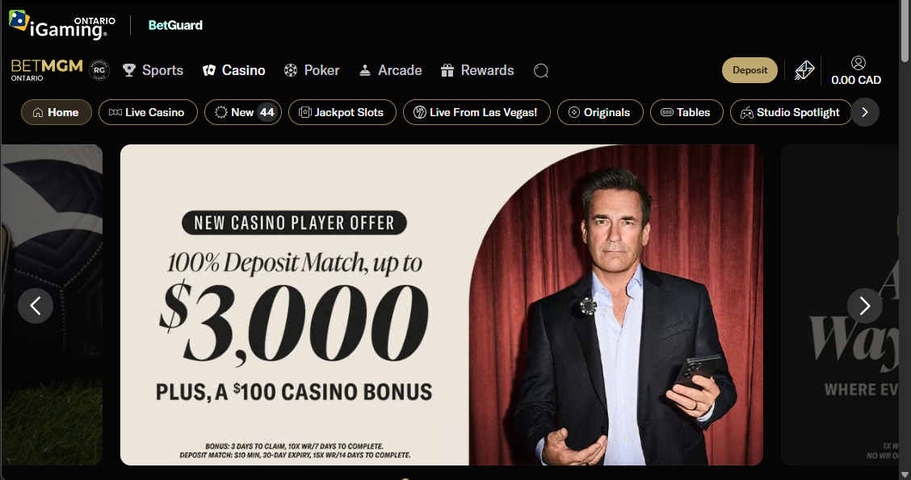
Once verified, the Withdraw option was accessible under the ‘My Profile’ icon at the top right. Withdrawal methods and limits were clearly listed. I could also track a pending withdrawal and cancel it when available. But the withdrawn amount became unavailable from my playable balance immediately after submitting the request.
Winner: Bet99 Ontario

Verification and Security Checks: BetMGM Offers Automated Verification
Both Bet99 ON and BetMGM ON required account verification before I could play with real money. I had to provide proof of identity and address to complete the process.
Bet99 Ontario let me browse the site before verification, but restricted access to the Cashier. Verification required taking an image of a government-issued identity card, driver’s licence, passport, or permanent resident card. A passport or permanent resident card also required proof of address issued within the previous 90 days. During testing, I used my identity card and my account was verified instantly, although the operator says it can take up to 48 hours.
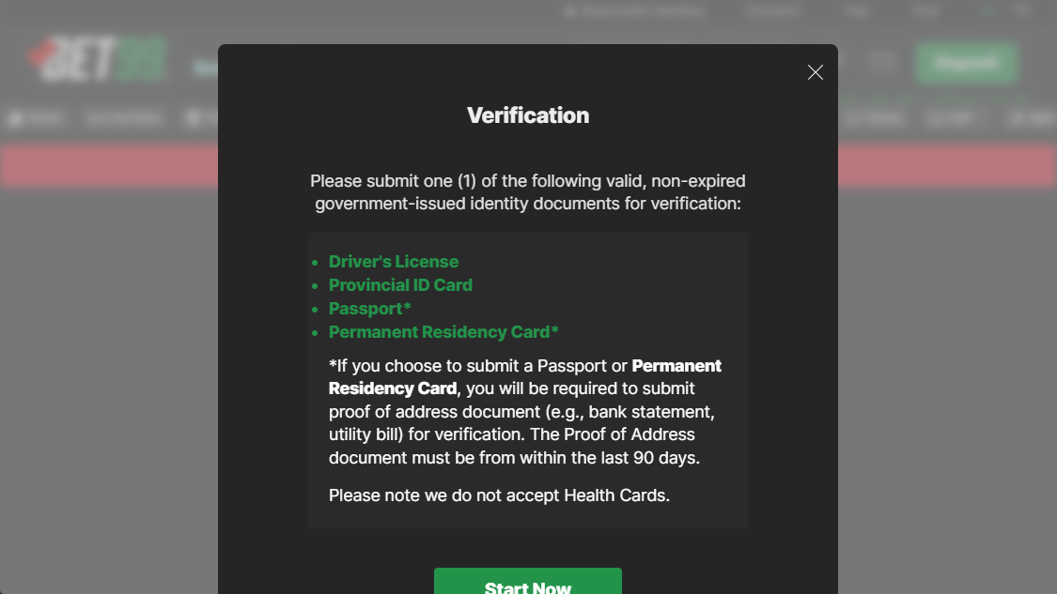
As for BetMGM Ontario, platform discovery was suspended until account verification was cleared. Luckily, my account verification was automatic. But there is a manual option where players must upload a selfie holding their Canadian ID along with proof of address documents, a process that can take 24 to 48 hours.
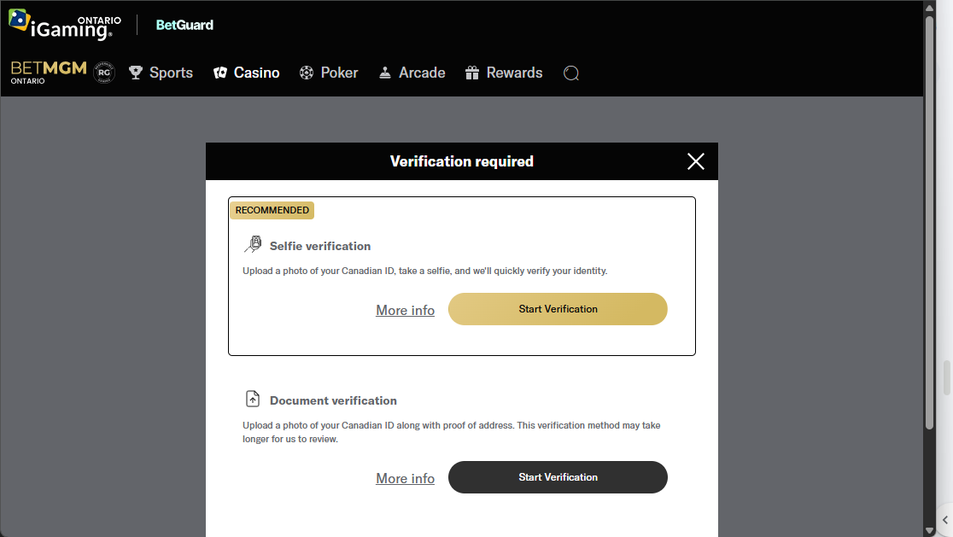

Winner: BetMGM Casino Ontario

Payment Methods Variety: BetMGM Ontario Offers a Wider Selection
An important part of my Bet99 vs. BetMGM Ontario payout test review was knowing which payout options were available on each platform. At Bet99 Ontario, Interac, Visa, MasterCard, Instadebit, and PayPal were available. But what stood out more was the $20 minimum for deposits and payouts, higher than what most Ontario licensed sites provide. Also, I found the payout options to be more limited than what top sites offer.
From my BetMGM Casino review, I found the operator supports nine payment options. These include Interac, Visa, MasterCard, PayPal, Apple Pay, Trustly, and Bank wire transfer, GAMEON Card, and BetMGM gift card. Do note the GAMEON card and the BetMGM gift card are exclusively for deposits. While deposits have a $10 minimum, payouts require a $20 minimum but the maximums can go as high as $50,000 depending on the banking option used.
Winner: BetMGM Ontario

Withdrawal Processing Times Compared: BetMGM Ontario is Faster and Has More Flexible Options
While both Bet99 and BetMGM charge no extra fees for deposits and withdrawals, their withdrawal processing times differ.
For Bet99 Casino Ontario’s five payout options, I found PayPal to be the fastest. It only took 12 hours for my withdrawal to hit my account. I initially used Interac to make my first deposit and later found that my withdrawal took about a day and a half to arrive. PayPal offered instant deposits and payouts in under 24 hours. However, this was only after completing the required ID checks, which I did immediately after signing up.
My BetMGM ON payout test took a similar trajectory as my experience on Bet99 Ontario. I used Interac to fund my account and later withdraw my winnings, but the payout took almost two days to reach my account. I appreciated BetMGM’s wider range of payout options, but PayPal was the only method I found that delivered same-day payouts.
Winner: BetMGM Ontario

Gaming on Mobile: BetMGM Ontario App Offers a More Personalized Experience
As one who prefers playing casino games on the go, I’m pleased to report that both Bet99 and BetMGM offer Ontario players not just a mobile-friendly site, but also dedicated mobile apps for iOS and Android.
After using the Bet99 Ontario app on my iPhone, I had access to the entire casino game library and enjoyed a seamless session while playing a few quick blackjack hands. I liked that the user interface was identical to the desktop platform, which also made cashing out straightforward.

However, after looking at other real player Bet99 Ontario reviews, I quickly discovered the Bet99 Ontario app for Android had a 3.2 star-rating and 100,000+ downloads on Google Play Store. Many players complained about annoying ads, poor customer service, and lengthy withdrawals.
Compared to my Bet99 Ontario app review, BetMGM Casino ON felt smoother and faster. The graphics felt sharper, the account features were intuitive, and the tap-to-cashier function made topping up and withdrawing on mobile fast and seamless.
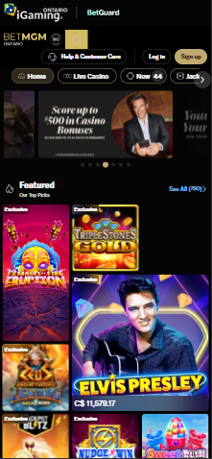
User ratings on Google Play Store and Apple App Store were generally strong (4.6 out of 5 stars on Google Play and 3.7 out of 5 stars on the App Store). And while most reviews were positive, a few mentioned slower withdrawals and occasional bugs after updates.
Winner: BetMGM Casino Ontario

Customer Support Comparison: Which is Better?
Among the more prominent differences I discovered during this Bet99 and BetMGM Ontario comparison review was in its customer support experiences.
While both offer multiple support options, those at Bet99 Ontario enjoy round-the-clock customer service available in both English and French. However, the platform only offers live chat and email support via support-on@BET99.ca.
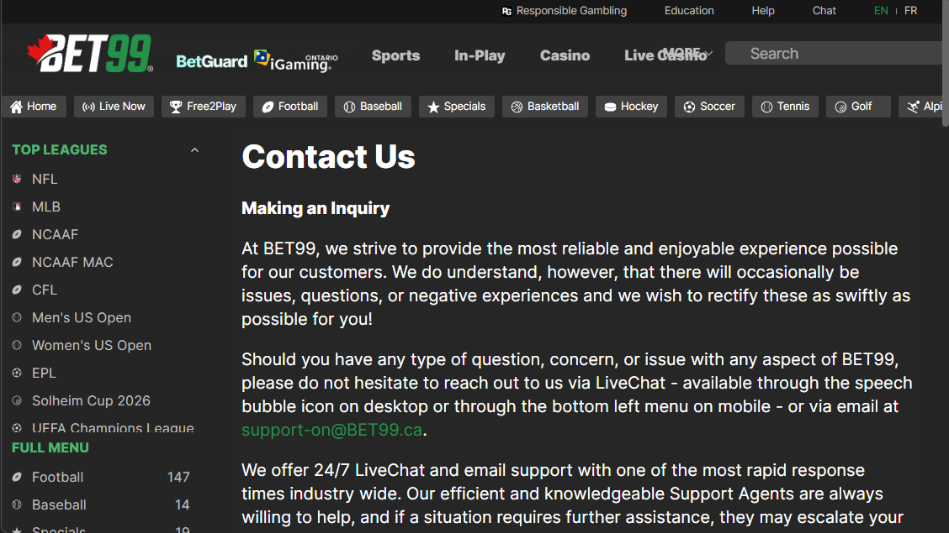
I liked that I could access Bet99 live chat even before signing up, but it was disappointing to only chat with Betsy, an AI agent who felt very human at first as it didn’t deflect any of my questions. But after a while, Betsy couldn’t answer questions like ‘What is the minimum withdrawal?’
Worth noting is there’s a Help Centre with various sections including My Account, Payments, KYC Verification, and more. But I did find this section less resourceful than what I found at BetMGM Ontario.
BetMGM, on the other hand, earns full marks for offering all key customer support options: live chat, email, and phone. During testing, I reached out to the 24/7 live chat and was connected to a real agent in under two minutes. I appreciated the Ontario-specific phone line (1-343-488-5355) along with the Ontario-specific email (support@on.betmgm.ca), which means Ontario players get tailored support for faster, more efficient resolutions.
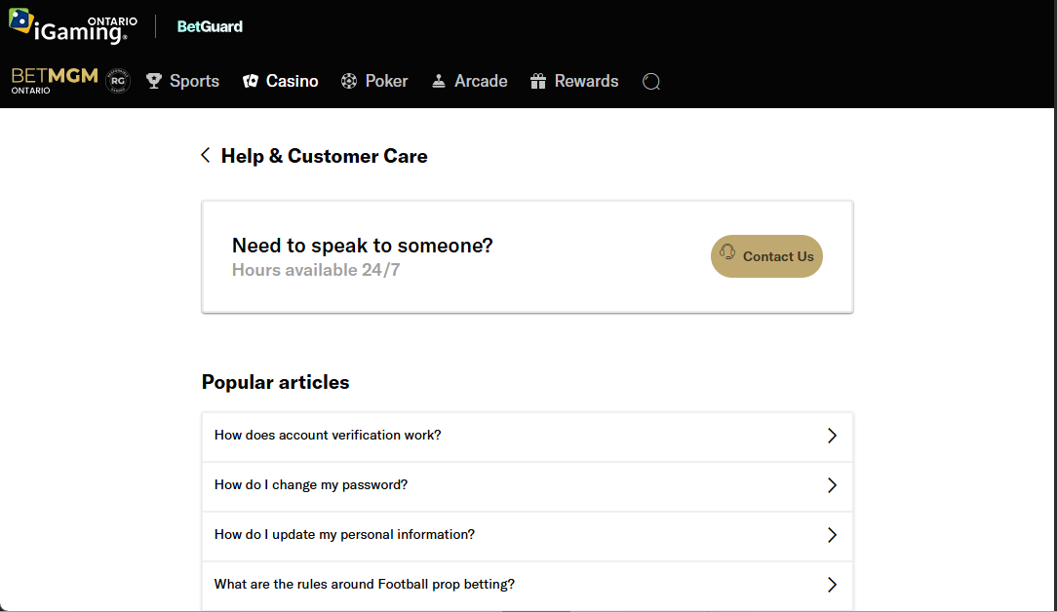
All support options were easy to access via the ‘Help & Customer Support’ on the top navigation. But do note that support is only available in English.
Winner: BetMGM Casino Ontario

Responsible Gambling Tools: Bet99 Ontario Takes the Win
Both Bet99 and BetMGM Ontario have accessible responsible gambling toolkits. But what stood out more was how Bet99 ingrained setting deposit limits and gaming limits in the sign up process. On top of that, the ‘Responsible Gambling’ page was prominently visible at the top of the screen.
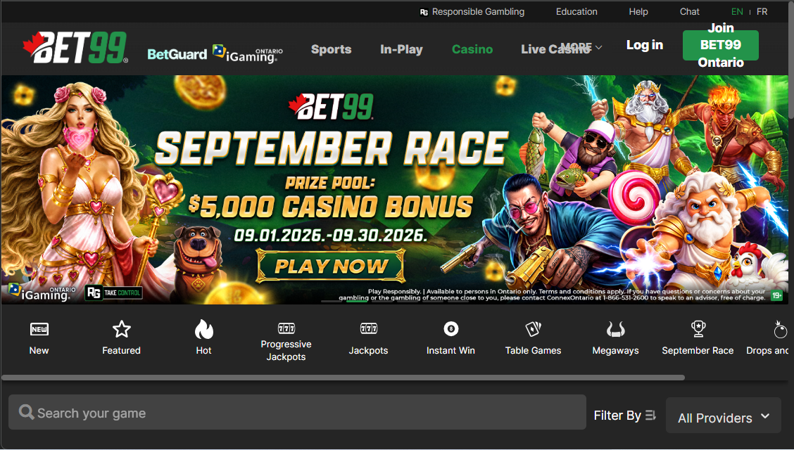
Among the RG tools available at Bet99 include deposit limits, loss limits, wager limits, session reminder limits, timeouts, self exclusion, and complete bet and transaction history.
As for BetMGM Ontario, player protection tools like deposit limits and session time caps were available, but they were not as prominently displayed as on Bet99 Ontario. I found the tools under the ‘Responsible Gambling’ tab in the footer menu or on the ‘Account Details’ menu.

As one of the more unique pairings, BetMGM is integrated with the GameSense program, offering local responsible gambling resources to ON players. I liked that the page featured a ton of gambling tips and links to third-party organizations such as ConnexOntario.

Winner: Bet99 Ontario

Bet99 vs. BetMGM: Which Pays Out Faster in Ontario?
Both Bet99 and BetMGM Ontario deserve a sign up if you don’t have an account already. They both deliver a well-rounded experience with a trustworthy reputation, thousands of casino games, reliable banking options, and solid mobile experiences.
However, if you consider which one pays out faster, I would go with BetMGM Casino Ontario. Although only its PayPal option offered same day payouts, the automated verification, wider selection of withdrawal methods, and Ontario-specific support scored the operator extra points. Nonetheless, Bet99 Ontario remains a great option for Ontario gamers who prefer a simple layout and more intentional responsible gambling efforts.
